**Replace, attach & Modify IAM Roles with EC2 using CLI**

1. Create two IAM roles **“myiams3role1”** & **“myiams3role2”** assign **s3fullaccess** to them.
2. Create EC2 instance.
3. Login to EC2 using CLI.
4. Assign role **“myiams3role1”** to EC2 instance using CLI:

**Command: aws ec2 associate-iam-instance-profile --instance-id i-06630666d37381864 --iam-instance-profile Name=myiams3role1**

**Output:**

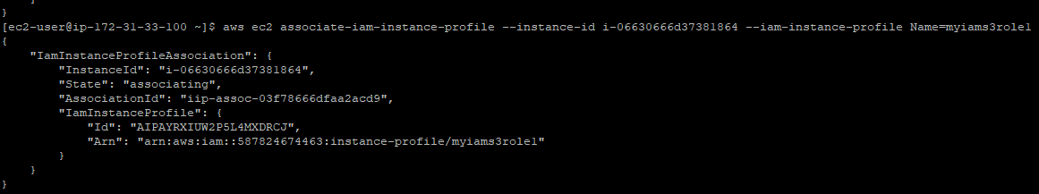

1. Create S3 Bucket **“sneha74”** and object **“abcd.txt”** and upload object into bucket then use sync command to copy all local files into bucket using IAM role **“myiams3role1”**

**Output:**

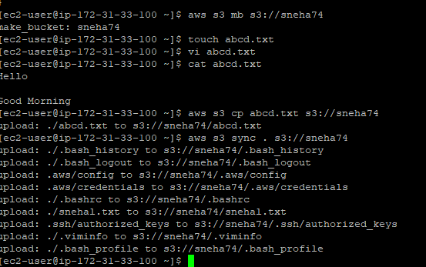

1. Run the command to get the E2 configuration,(**Ex: Instance Id, Association Id, Running Role**)

**Command: aws ec2 describe-iam-instance-profile-associations**

**Output:**

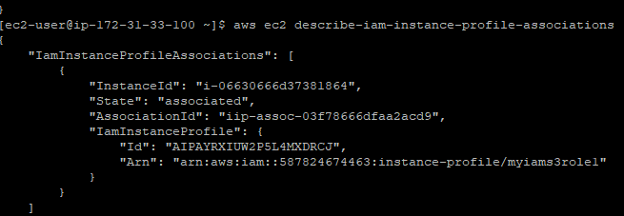

**Note:** Please take association id for the role, which is assign to EC2, Also you can refer the step 4 to get association Id where we have assigned the role.

1. Replace EC2 IAM role on running EC2 instance.

**Command: aws ec2 replace-iam-instance-profile-association --association-id ip-assoc-03f78666dfaa2acd9 --iam-instance-profile Name=myiams3role2**

**Output:**

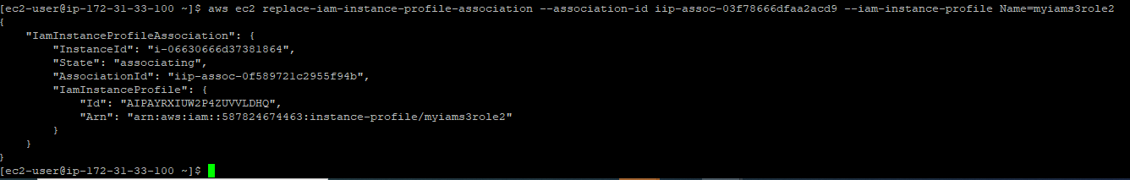

Successfully IAM role “myiams3role2” assign on running EC2 instance.

1. Now create new object “**pqrs.txt**” and upload in bucket **“sneha74”** using different role **i.e “myiams3role2”**

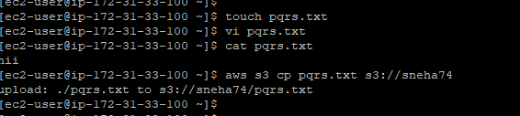

Successfully uploaded object in bucket using different IAM role.

1. List of all objects:

